VAPT-TASK 02 Report
Mohammed Hussain Shaikh

Contents
VAPT-TASK 02 Report 1
Introduction 3
Metasploitable 2 Machine Scan 4
Reconnaissance of Metasploitable 2 Machine 8
Exploit Metasploitable 2 Machine 10
Exploit Windows 7 Machine 12
Exploit DVWA with sqlmap 15
Lessons Learnt 21
References 22

Introduction
In this report I am going to explain the below findings with the help of screenshots and diagrams:

- Scan Metasploitable 2 machine with Nmap and OpenVAS.
- Use Shodan to perform reconnaissance on Metasploitable 2 machine.
- Exploit Metasploitable 2 machine with Metasploit Framework.
- Exploit Windows 7 Machine.
- Exploit DVWA with sqlmap for SQL injection.

Metasploitable 2 Machine Scan
Nmap Scan of Metaploitable2 machine
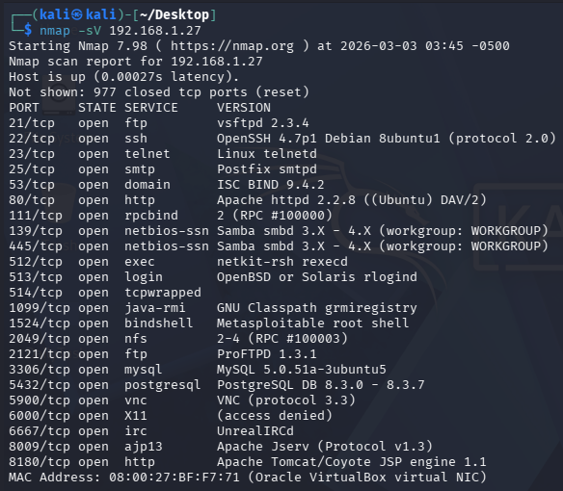

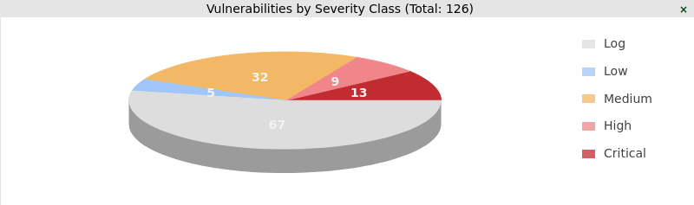
OpenVAS Scan of Metasploitable2 machine

ScanID | Vulnerability | CVSS Score | Priority | Host
001 | The rexec service is running | 10.0 | Critical | 192.168.1.27
002 | OS EOL Detection | 10.0 | Critical | 192.168.1.27
003 | MySQL Default Credentials | 9.8 | Critical | 192.168.1.27
004 | Apache Tomcat AJP RCE Vulnerability | 9.8 | Critical | 192.168.1.27
005 | VNC Brute Force Login | 9.0 | Critical | 192.168.1.27
006 | UnrealIRCd Authentication Spoofing Vulnerability | 8.1 | High | 192.168.1.27
007 | FTP Brute Force Logins With Default Credentials | 7.5 | High | 192.168.1.27
008 | rsh Unencrypted Cleartext Login | 7.5 | High | 192.168.1.27
009 | TWiki Cross-Site Request Forgery Vulnerability | 6.8 | Medium | 192.168.1.27
010 | Anonymous FTP Login | 6.4 | Medium | 192.168.1.27
011 | TCP Timestamps Information Disclosure | 2.6 | Low | 192.168.1.27

The rexec service is running
CVE ID: CVE-1999-0618
Patch: Disable the rexec service and use alternatives like SSH instead.
OS EOL Detection
CVE ID:
Patch: Update the OS on the remote host to a version which is still supported and receiving security updates by the vendor.
MySQL Default Credentials
CVE ID: CVE-2024-22901
Patch: Change the password as soon as possible.
Apache Tomcat AJP RCE Vulnerability
CVE ID: CVE-2020-1938
Patch: Update Apache Tomcat to version 7.0.100, 8.5.51, 9.0.31 or later.
VNC Brute Force Login
CVE ID:
Patch: Change the password to something hard to guess or enable password protection at all.
UnrealIRCd Authentication Spoofing Vulnerability
CVE ID: CVE-2016-7144
Patch: Update to version 3.2.10.7, 4.0.6 or later.
FTP Brute Force Logins With Default Credentials
CVE ID: CVE-2020-36915
Patch: Change the password as soon as possible.
rsh Unencrypted Cleartext Login
CVE ID: CVE-1999-0651
Patch: Disable the rsh service and use alternatives like SSH instead.
TWiki Cross-Site Request Forgery Vulnerability
CVE ID: CVE-2009-4898
Patch: Upgrade to TWiki version 4.3.2 or later.
Anonymous FTP Login
CVE ID: CVE-1999-0497
Patch: If you do not want to share files, you should disable anonymous logins.
TCP Timestamps Information Disclosure
CVE ID:
Patch: To disable TCP timestamps on linux add the line 'net.ipv4.tcp_timestamps = 0' to /etc/sysctl.conf. Execute 'sysctl -p' to apply the settings at runtime. To disable TCP timestamps on Windows execute 'netsh int tcp set global timestamps=disabled'.

100-Word email to developers with PoC:
Subject: Critical Vulnerabilities Identified in OpenVAS/GVM Scan – Immediate Action Required
Dear Development Team,
Our recent OpenVAS/GVM scan of host 192.168.1.27 identified multiple critical vulnerabilities requiring urgent remediation. Critical issues include rexec service exposure (CVSS 10.0), OS End-of-Life detection (10.0), MySQL default credentials (9.8), Apache Tomcat AJP RCE (9.8), and VNC brute-force susceptibility (9.0).
PoC examples:
• MySQL default login successful using “root”.
• AJP port 8009 allowed file inclusion test confirming RCE exposure.
• Anonymous FTP login granted directory access.
Immediate actions: disable insecure services (rexec, rsh), patch/upgrade OS and Tomcat, enforce strong credentials, and restrict external access.
Please prioritize remediation and confirm patch timelines.
Regards,
Security Team

Reconnaissance of Metasploitable 2 Machine
- Shodan scan for Metasploitable 2 machine.
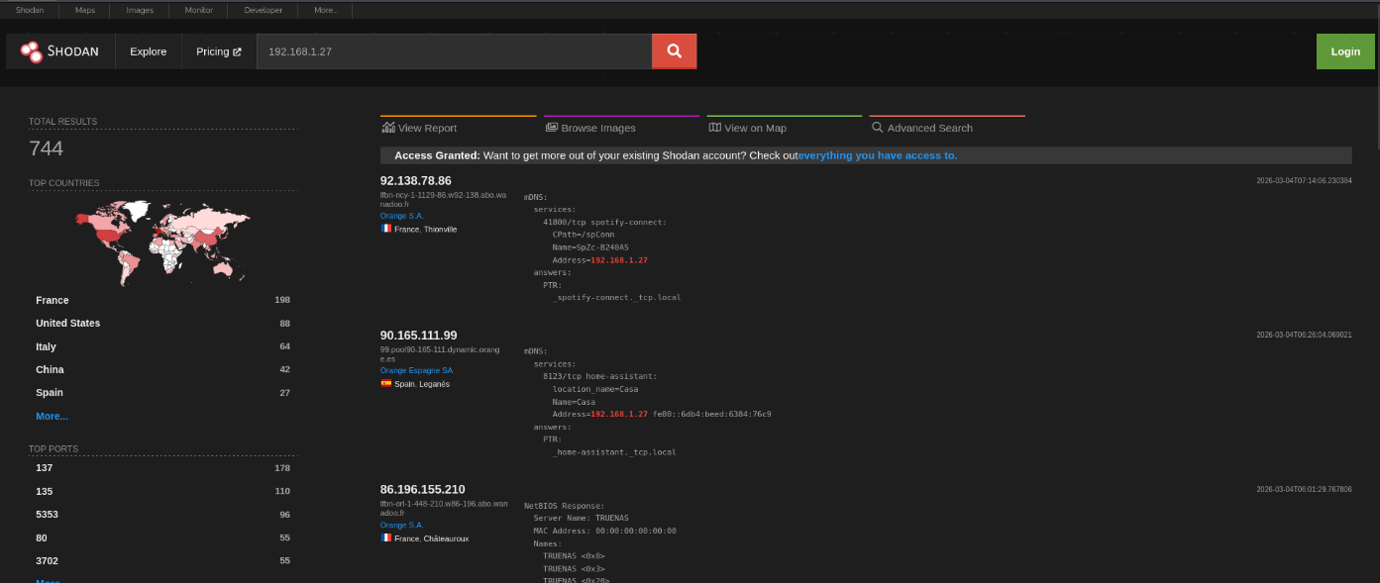

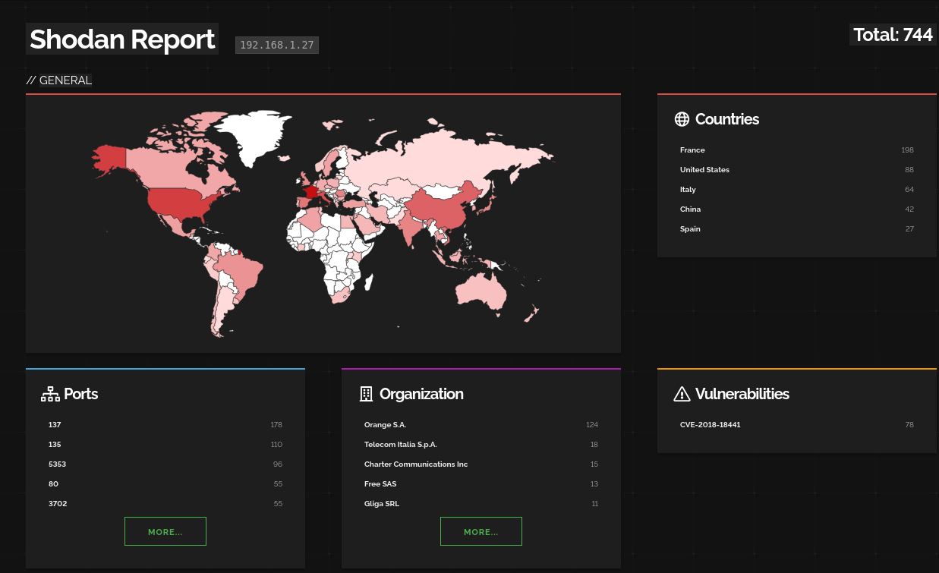
- Shodan Report.

- Open Ports.
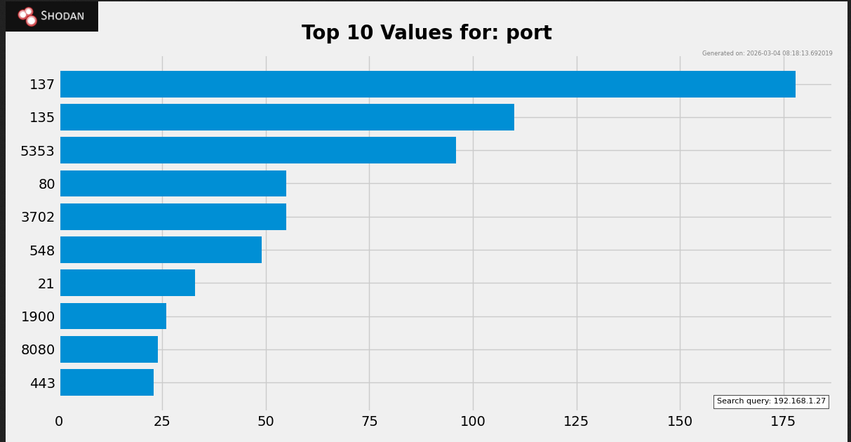

50-word recon summary:
A global Shodan search for 192.168.1.27 produced 744 hits, mostly from France, the US, Italy, China, and Spain. 137, 135, 5353, 80, 3702, 21, 1900, 8080, and 443 are frequently open ports. Telecom Italia and Orange S.A. are affiliated companies. Vulnerability CVE-2018-8440 was found, suggesting a possible risk of remote exploitation.

Exploit Metasploitable 2 Machine
- Run sudo msfconsole.
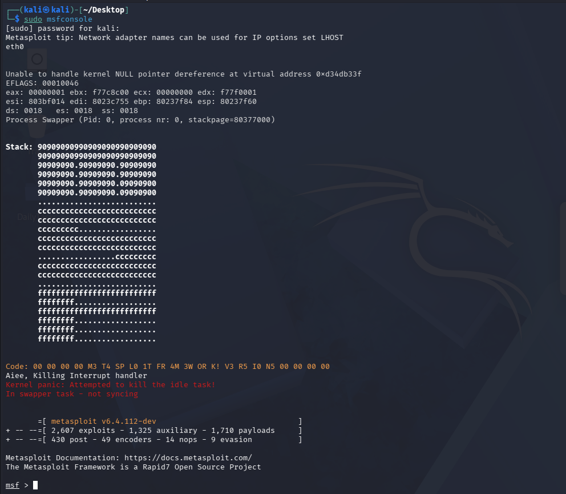

- Search the exploit.
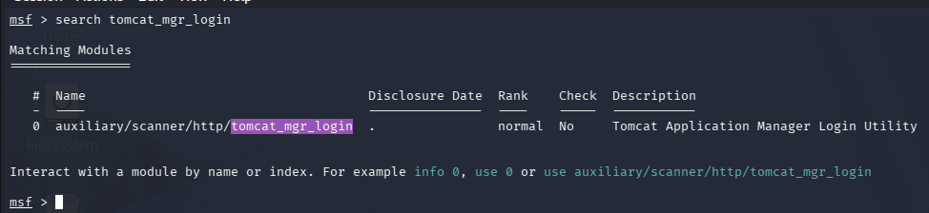

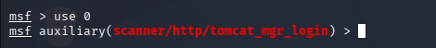
- Use the exploit.

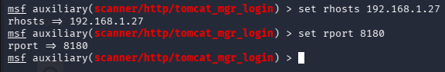
- Set the necessary information.

- Run the exploit.
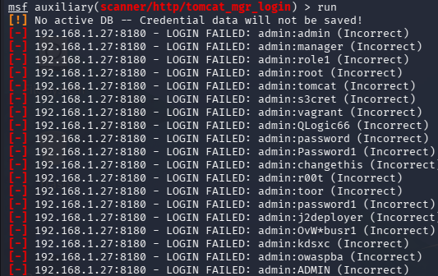

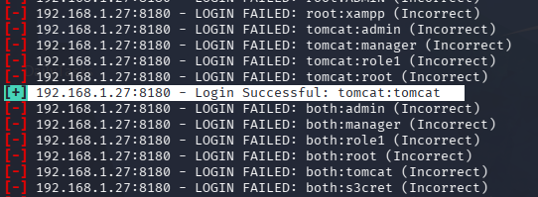
- Correct credentials found.

Exploit-DB for PoC:
This module can be used to execute a payload on Apache Tomcat servers that have an exposed "manager" application. The payload is uploaded as a WAR archive containing a jsp application using a PUT request. The manager application can also be abused using /manager/html/upload, but that method is not implemented in this module.

Exploit Windows 7 Machine
- Run sudo msfconsole.
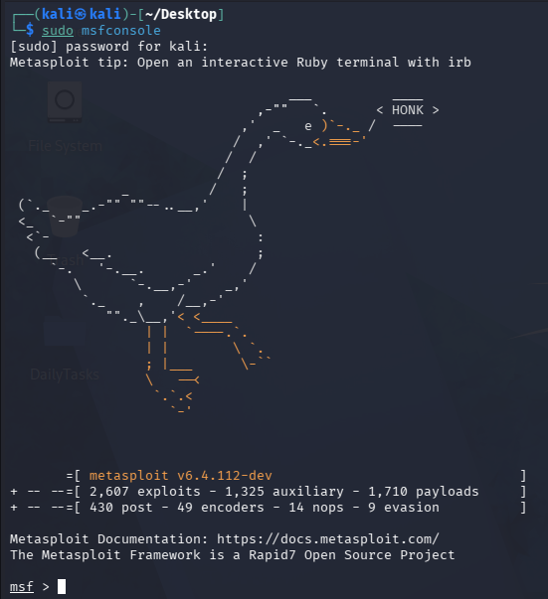

- Search the eternalblue exploit.
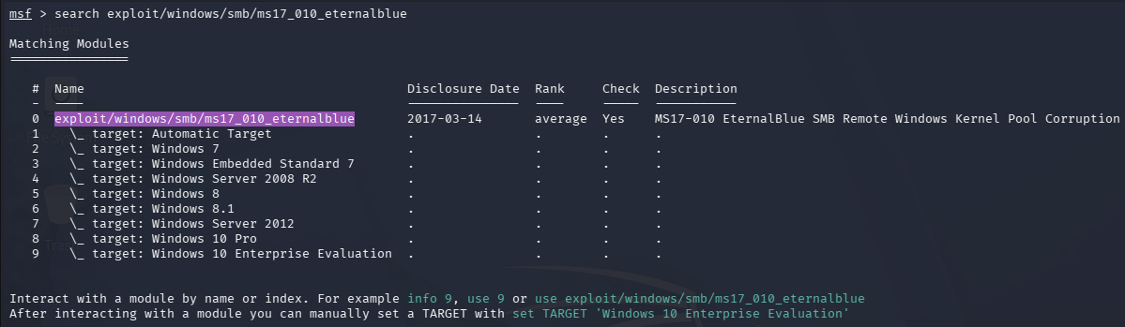

- Use the exploit.
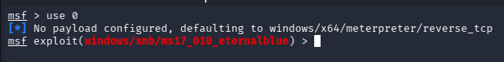

- Record the Ip address of Windows 7 machine, which is 192.168.1.42
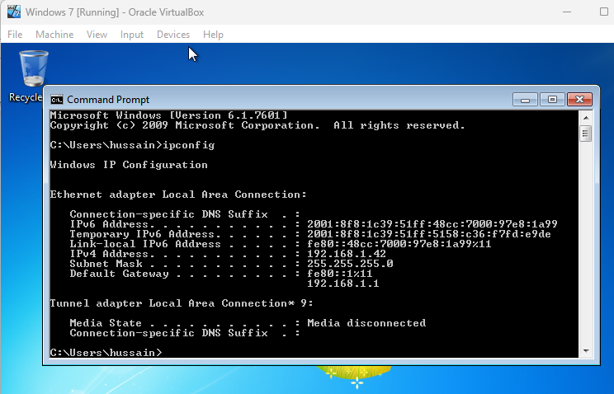

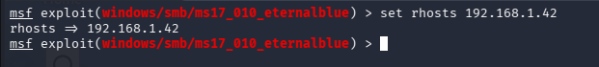
- Set the rhosts to the Windows 7 machine.

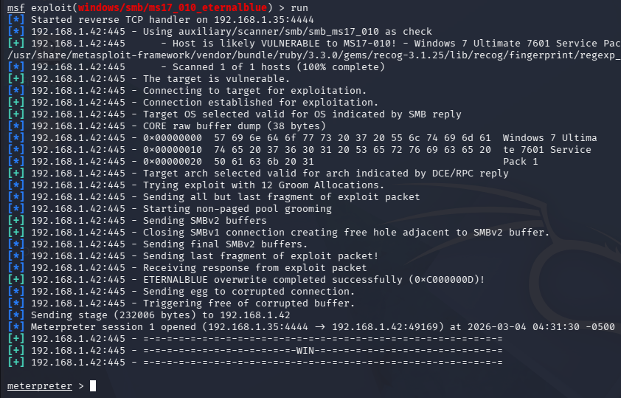
- Run the exploit. As we can see below, we get a meterpreter session.

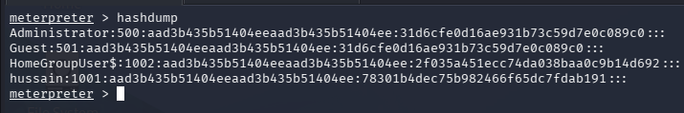
- View the hashdump.

Exploit DVWA with sqlmap
- DVWA Dashboard.
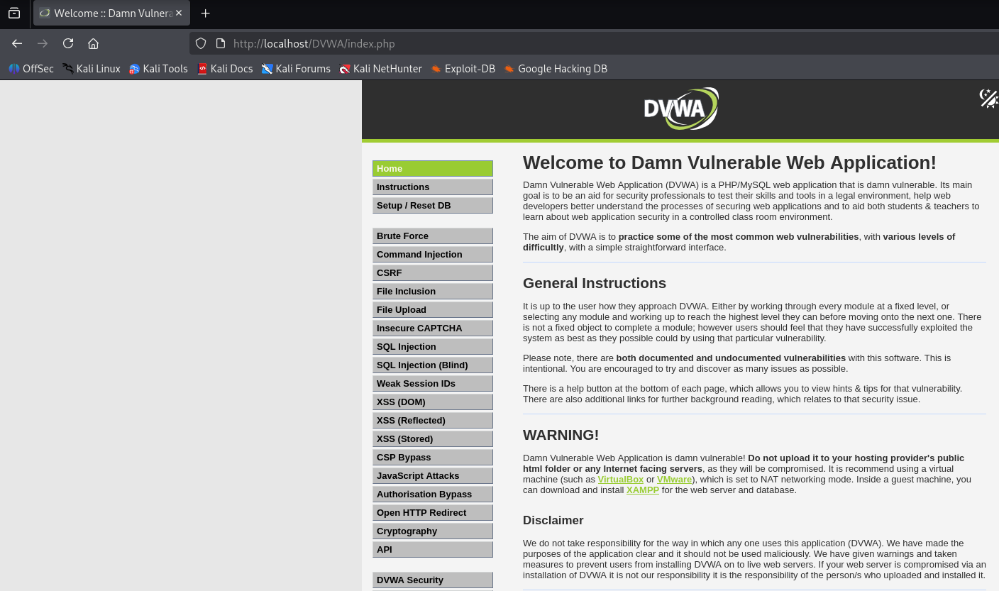

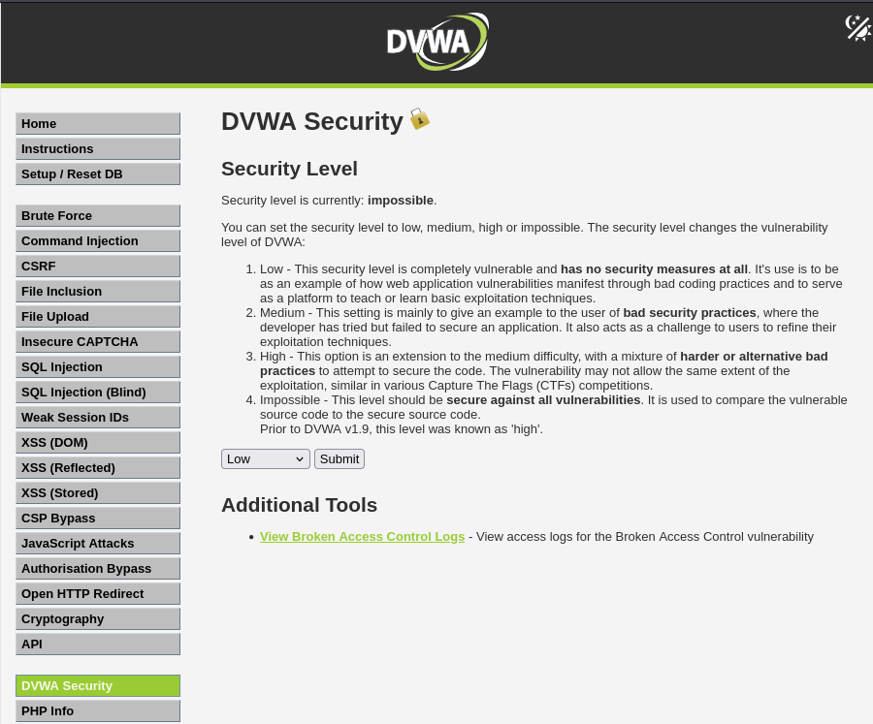
- Set security level to low.

- SQL Injection page for DVWA.
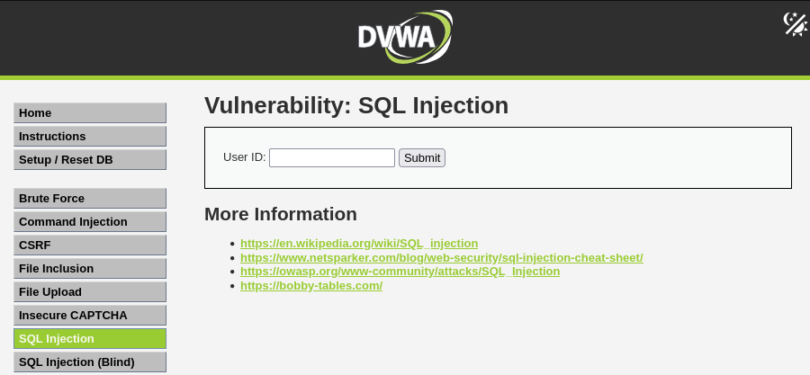

- The below shows id=1 is injectable parameter.
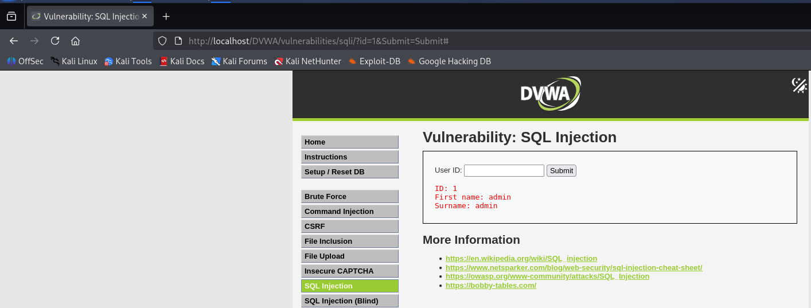

- Record the cookie value to perform SQL injection.
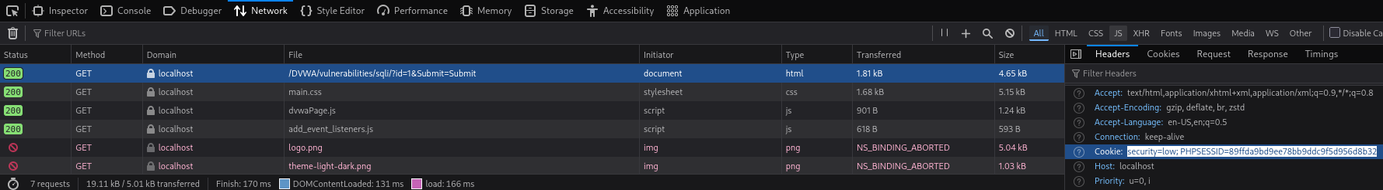

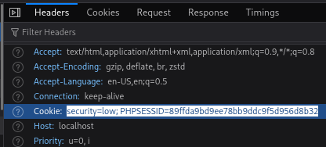

- Dumping all DVWA databases by performing SQL injection.

- Two available databases found.
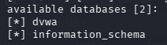

- Enumerate tables.

- Four tables found.
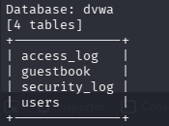

- Dump the ‘users’ table.

- Admin User details found.
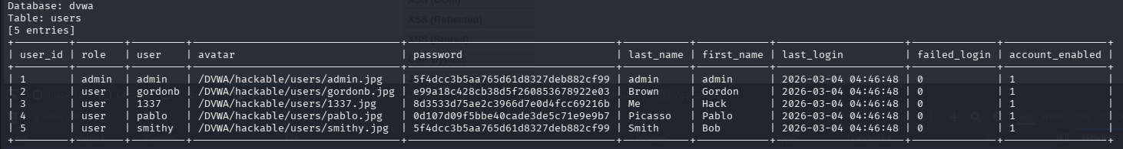

Input Sanitization method to prevent SQL Injection:
Use Prepared Statements:
Prepared statements are simple to write and easier to understand than dynamic queries, and parameterized queries force the developer to define all SQL code first and pass in each parameter to the query later. If database queries use this coding style, the database will always distinguish between code and data, regardless of what user input is supplied. Also, prepared statements ensure that an attacker cannot change the intent of a query, even if SQL commands are inserted by an attacker.

200-word PTES report

Penetration Testing Execution Standard (PTES) Report

Target: Damn Vulnerable Web Application
Testing Tool Referenced: sqlmap
Environment: Kali Linux

1. Pre-Engagement Interactions
Before testing, written consent was acquired. The scope was restricted to the DVWA instance that was hosted locally. Finding SQL injection vulnerabilities in the web application was the main goal of the testing.
2. Intelligence Gathering
To find possible attack surfaces, application pages and input parameters were examined. Because user-supplied input fields interact with the backend database, the SQL Injection module was found to be a high-risk entry point.
3. Threat Modeling
The primary threat identified was improper input validation leading to SQL injection, potentially allowing unauthorized database access, data extraction, or privilege escalation.
4. Vulnerability Analysis
Testing showed that unsanitized user input was accepted by the program. Inadequate validation controls and a lack of prepared statements made injection attacks more likely.
5. Exploitation
In the lab environment, automated testing confirmed the presence of SQL injection vulnerabilities under low security settings.
6. Post-Exploitation
Potential impact includes database enumeration and sensitive data disclosure.
7. Reporting & Remediation
It is recommended to implement prepared statements.

100-word non-technical summary:
In order to analyze the Damn Vulnerable Web Application's resistance to typical web application threats, a security assessment was carried out in a controlled laboratory setting. Finding database security flaws was the main goal of the testing. Vulnerabilities that, if ignored, could provide unauthorized access to private data were found throughout the examination. Despite the fact that the application was purposefully made susceptible for training, the results show the dangers that companies face when safe coding techniques are not used. To lower potential security concerns, it is advised to adopt the principle of least privilege, employ safe database handling techniques, and increase input validation.

Lessons Learnt
In this task I got to learn about how to scan for vulnerabilities using OpenVAS and analyse it. I also got to learn on how to perform reconnaissance using Shodan. Finally, I got to exploit Metasploitable 2 machine, Windows 7 machine and DVWA.

References
https://medium.com/@Aditya_2_1/hac-metasploitable-2-a-step-by-step-exploitation-guide-d87607e1d995
https://www.exploit-db.com/exploits/16317
https://huzzaifaasim.medium.com/exploiting-windows-smb-module-vulenerability-using-eternal-blue-exploit-metasploit-5fa3db5bab83
https://cheatsheetseries.owasp.org/cheatsheets/SQL_Injection_Prevention_Cheat_Sheet.html

